College of Computer Science and Artifical Intelligence in Wenzhou University
Web Application Development Report
Experiment: | PRACTICE 7
Class: |  | Name: | EMETUCHE WINNER CHIDIUTO | Student ID: | 18511160023
Classroom: |  | Date:

【1. Experiment Purpose】
1.1 To understand what is JavaScript;
1.2 To learn how to add JavaScript to your HTML page
1.3 To learn selection statement;
1.4 To learn loops statement
1.5 To learn how to debug pages

【2. Experiment Condition】
2.1 Personal Computer;

【3. Content and Requirements】
3.1. Create page with if statement
3.2. Create page with different if statement. Such as if else, if else-if else, and nested if else
3.3. Create page with switch statement.
3.4. Create page with for loops
3.5. Create page with while loops

【4. Experimental Procedure】
4.1 To fill the report.
【5. Results and Analysis】

3.1. Create page with if statement

let checkName=()=>{
input=="joe"?alert("hi joe, come in"):alert("youre not joe my friend !")
}

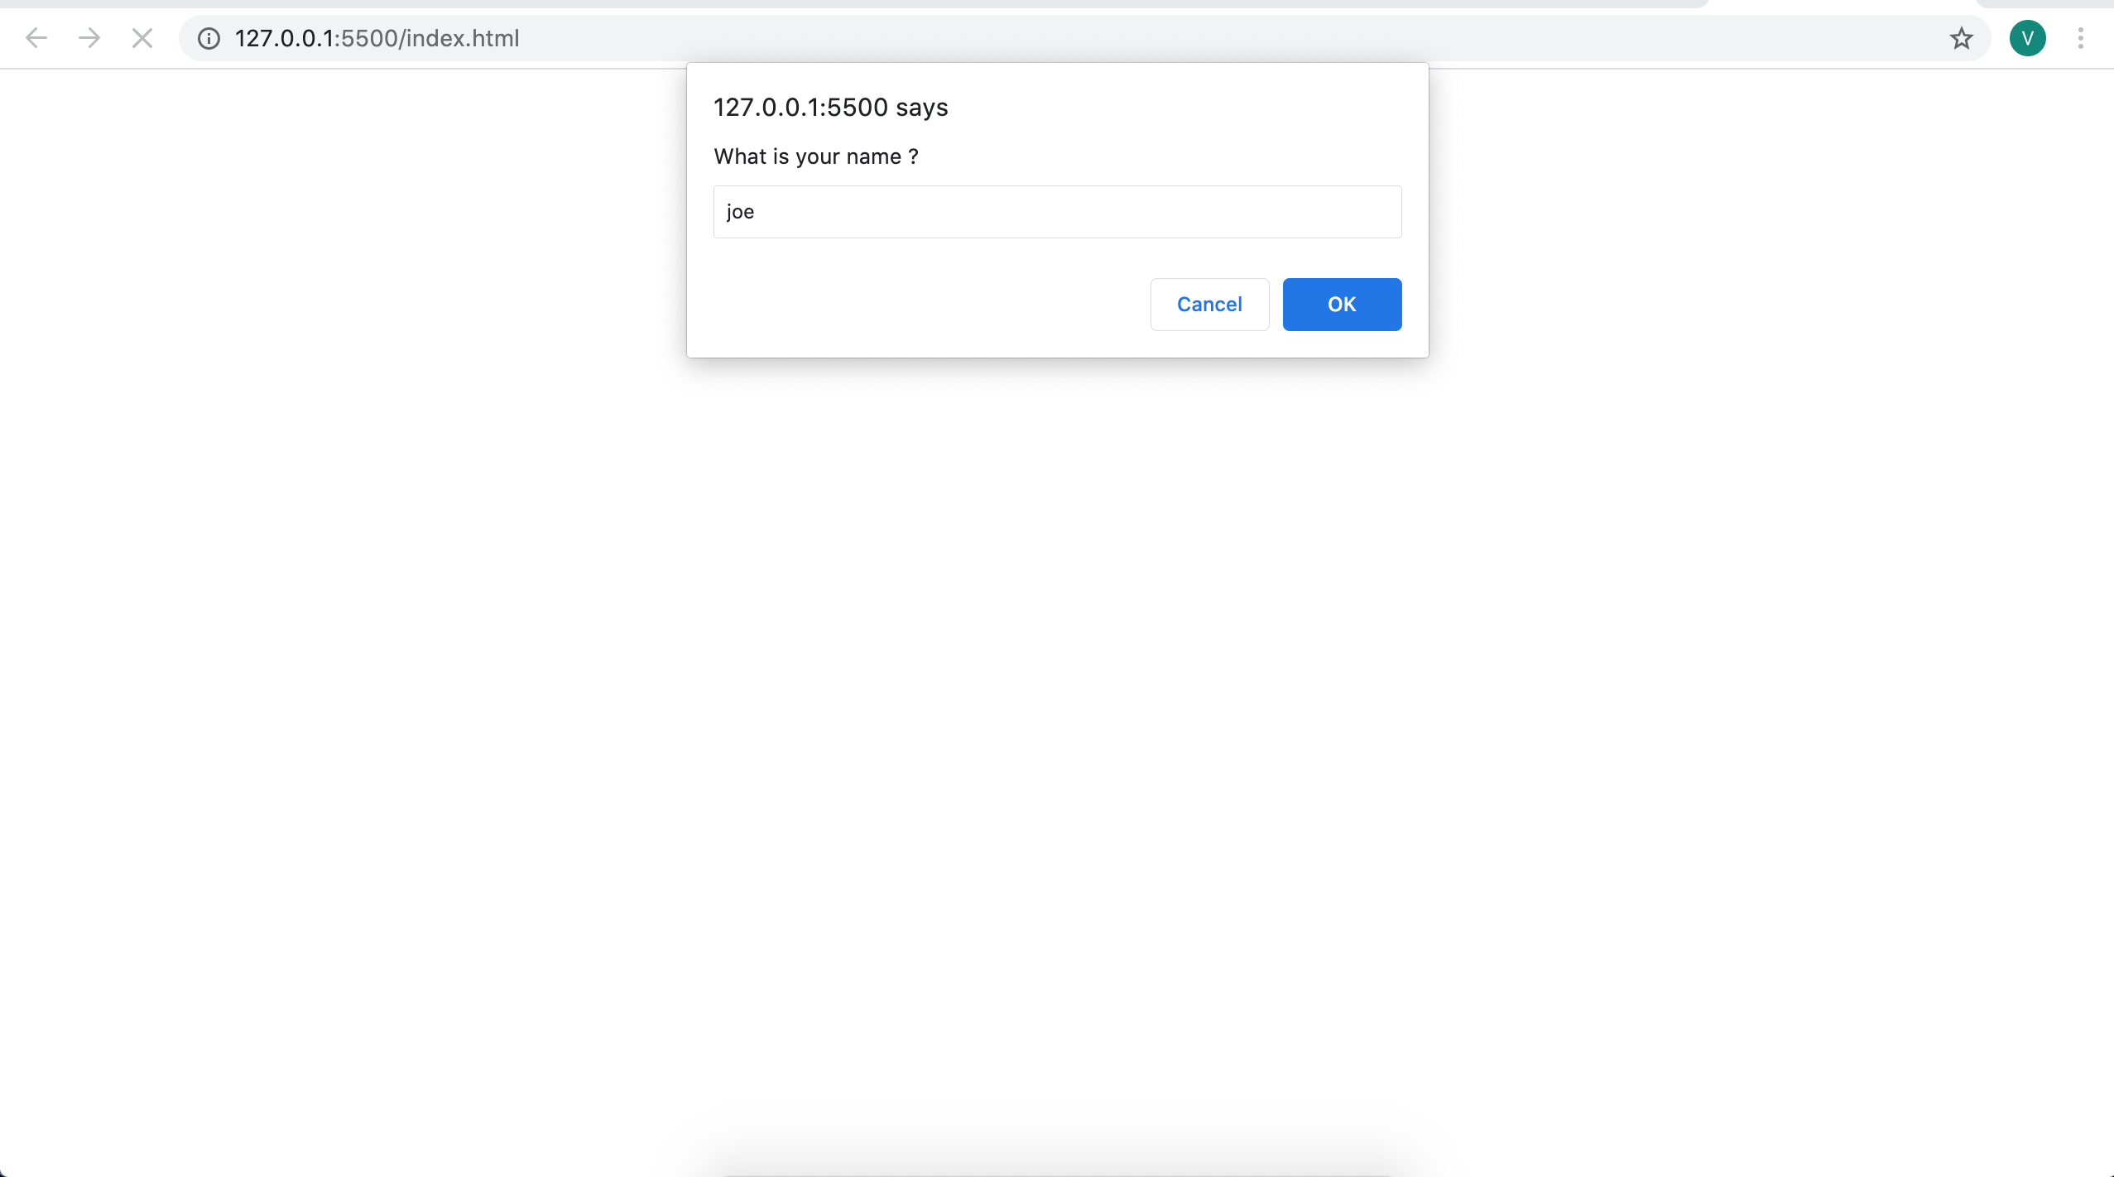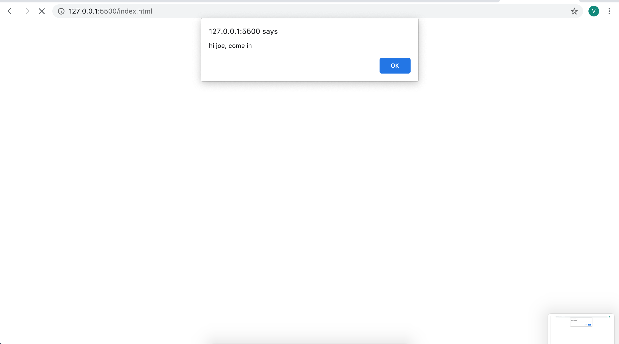

3.2. Create page with different if statement. Such as if else, if else-if else, and nested if else

let advancedNameCheck=()=>{
if(input=='joe'){
alert("hi joe, come in")
}else if(input=='martin'){
alert("youre not joe my friend !")
}else if(input=='victor'){
alert("Hi uncle, its been a long time !")
}
}

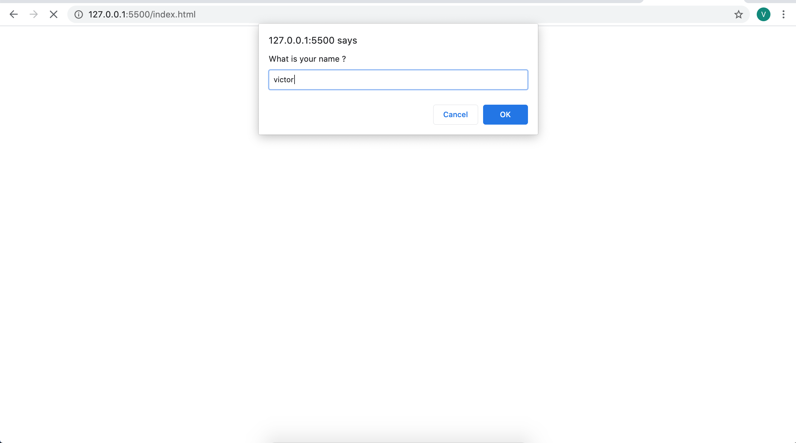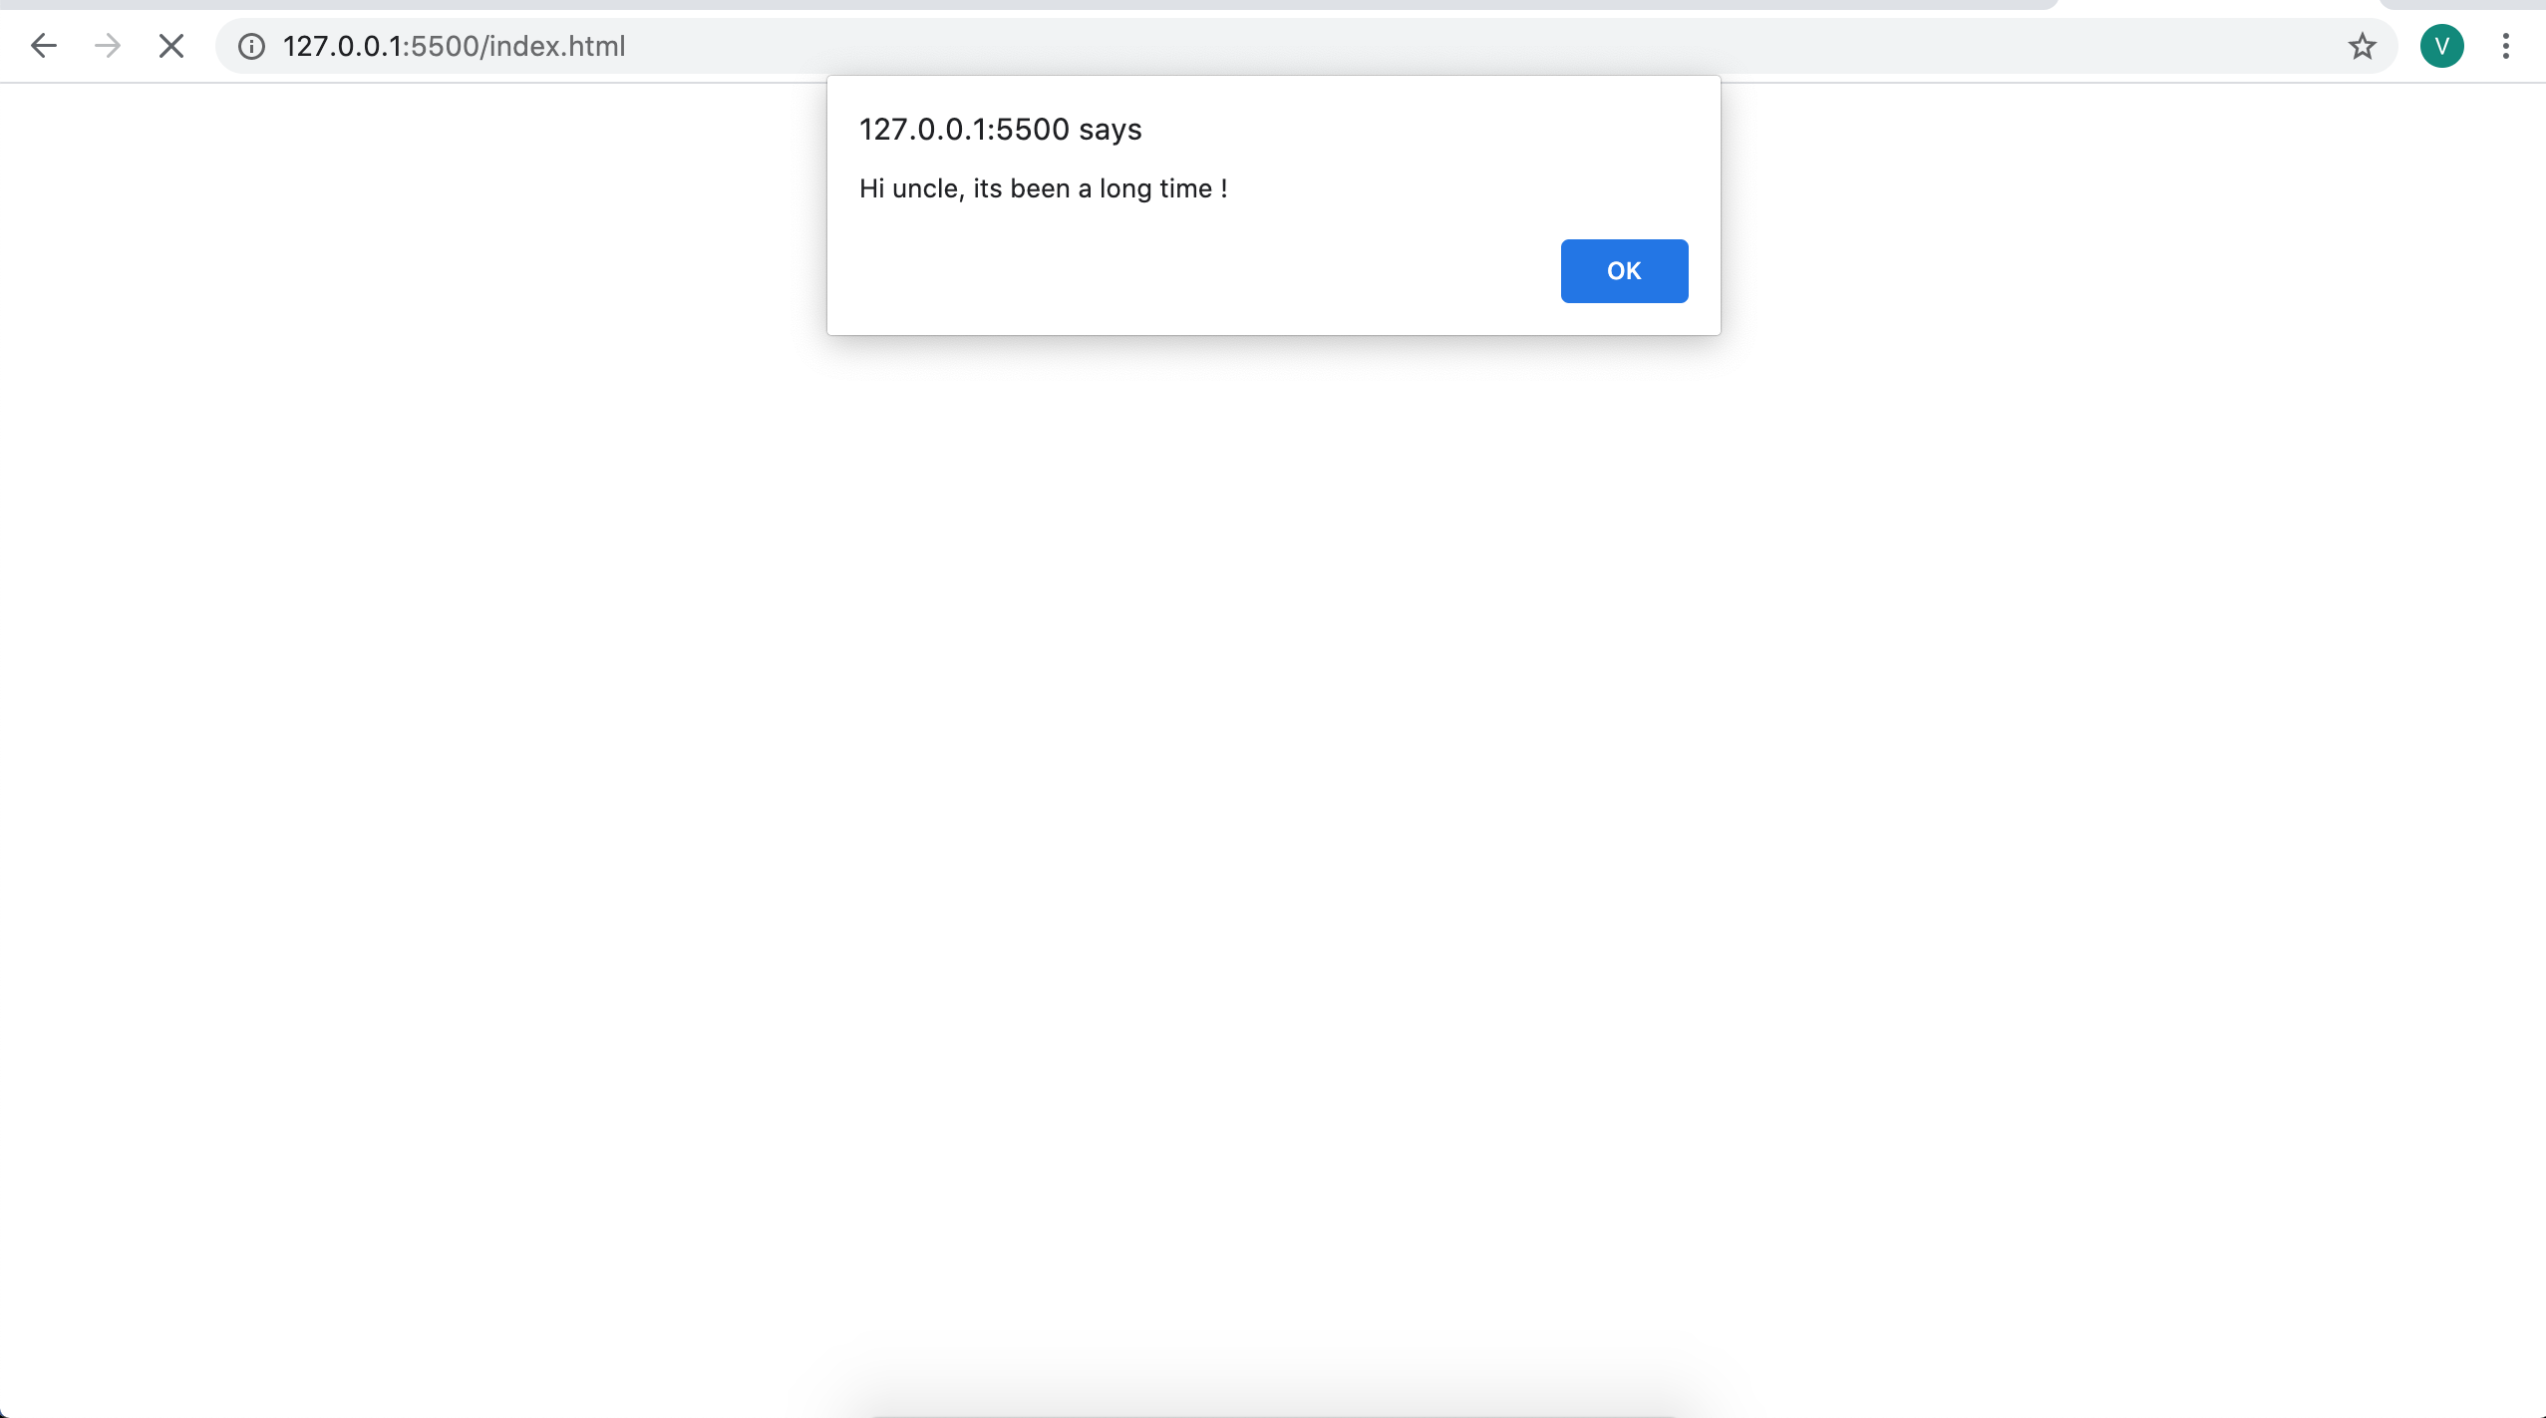

let checkNameSwitch=()=>{
switch(input){
case "joe":
alert("hi joe, come in")
break;
case "martin":
alert("youre not joe my friend !")
break;
case "victor":
alert("Hi uncle, its been a long time !")
break;
default:
break;
}
}

3.4. Create page with for loops
<!DOCTYPE html>
<html>
<head>
<title></title>
<head>
<body>
<div style="font-size:20px; font-family: sans-serif; padding-top:30px; padding-left:30px; ">
<span style="font-weight:bold; ">Practice 7</span>
-> 3.1. Create page with for loops
</div>
<div id="result" style="font-size:15px; font-family: sans-serif; padding-top:30px; padding-left:30px; height:400px; width:500px;" >
</div>
</body>
<script>
arry=[{'joe':''},{'martin':''},{'victor':''}];
let forLoopPage=()=>{
for(var i=0; i<arry.length; i++){
var inp=prompt(Object.keys(arry[i])+ " is my ");
arry[i][Object.keys(arry[i])]=inp;
}
for(var i=0; i<arry.length; i++){
var resultT=document.getElementById("result");
resultT.innerHTML+="<div>"+""+Object.keys(arry[i])+" is your "+ arry[i][Object.keys(arry[i])]+"</div>"
}
}
</script>

</html>

3.5. Create page with while loops

<!DOCTYPE html>
<html>
<head>
<title></title>
<head>
<body>
<div style="font-size:20px; font-family: sans-serif; padding-top:30px; padding-left:30px; ">
<span style="font-weight:bold; ">Practice 7</span>
-> 3.5. Create page with while loops
</div>
<div id="result" style="font-size:15px; font-family: sans-serif; padding-top:30px; padding-left:30px; height:400px; width:500px;" >
</div>
</body>
<script>
arry=[{'joe':''},{'martin':''},{'victor':''}];
let whileLoopPage=()=>{
var i=0;
while(i<arry.length ){
var inp=prompt(Object.keys(arry[i])+ " is my ");
arry[i][Object.keys(arry[i])]=inp;
i++
}
i=0;
while(i<arry.length ){
var resultT=document.getElementById("result");
resultT.innerHTML+="<div>"+""+Object.keys(arry[i])+" is your "+ arry[i][Object.keys(arry[i])]+"</div>"
i++
}
}
whileLoopPage();
</script>

</html>

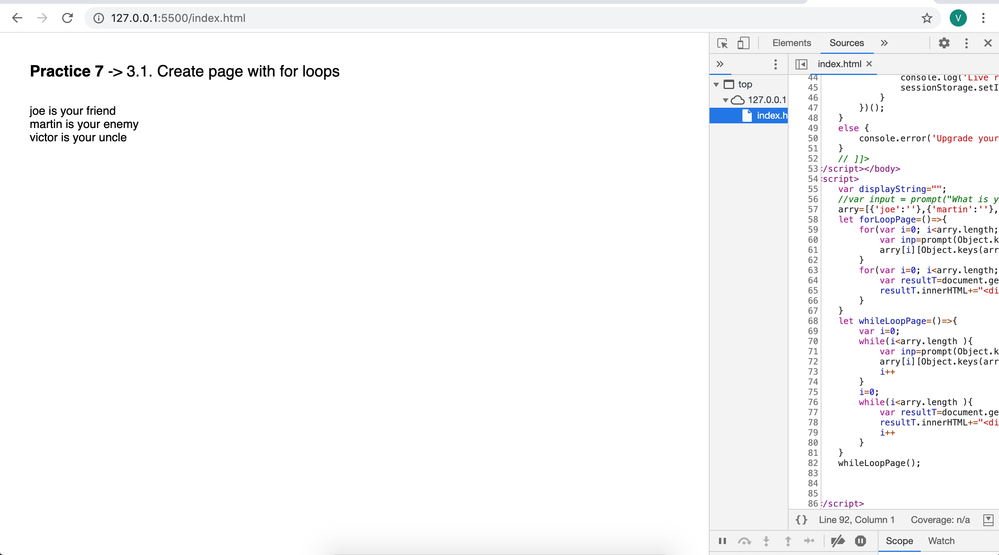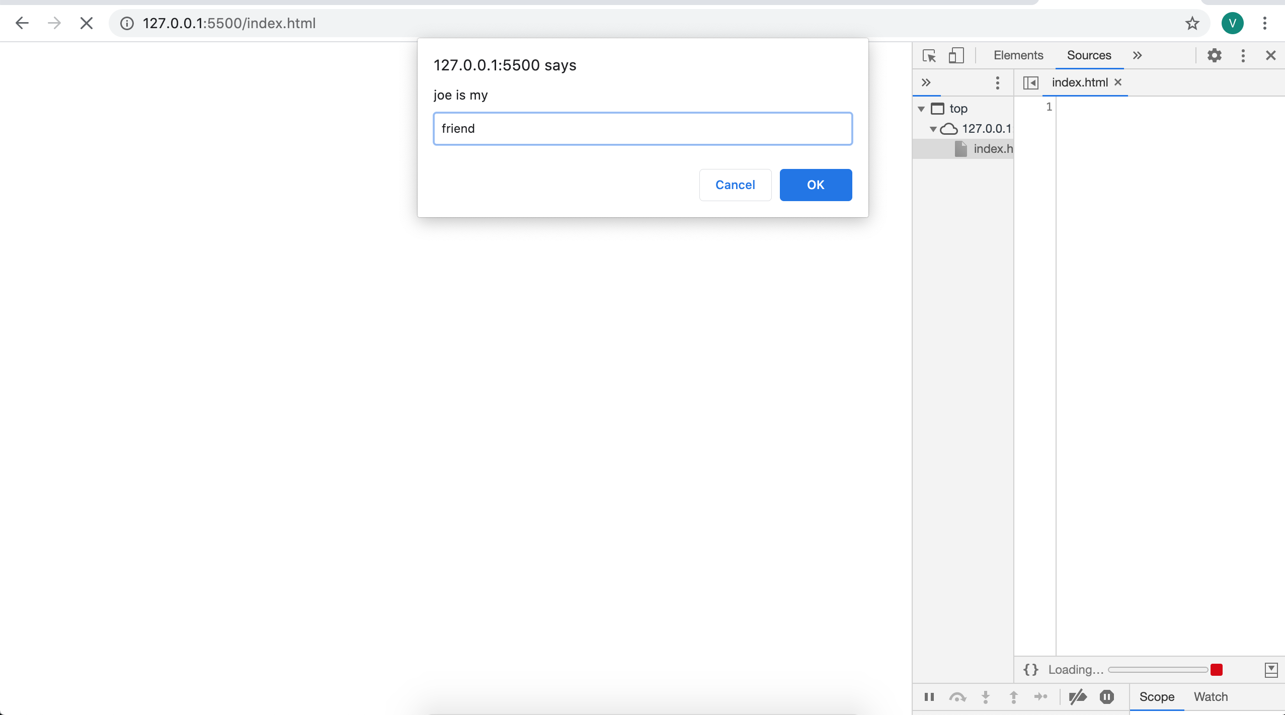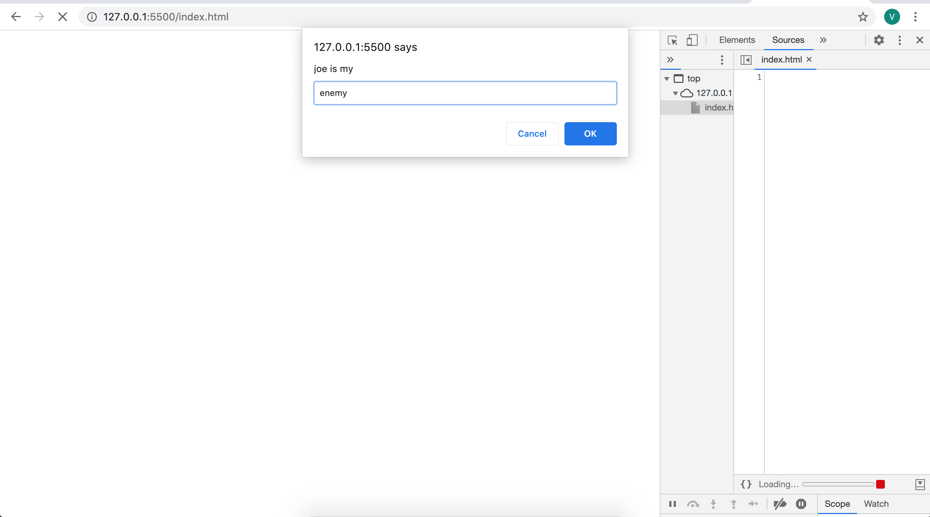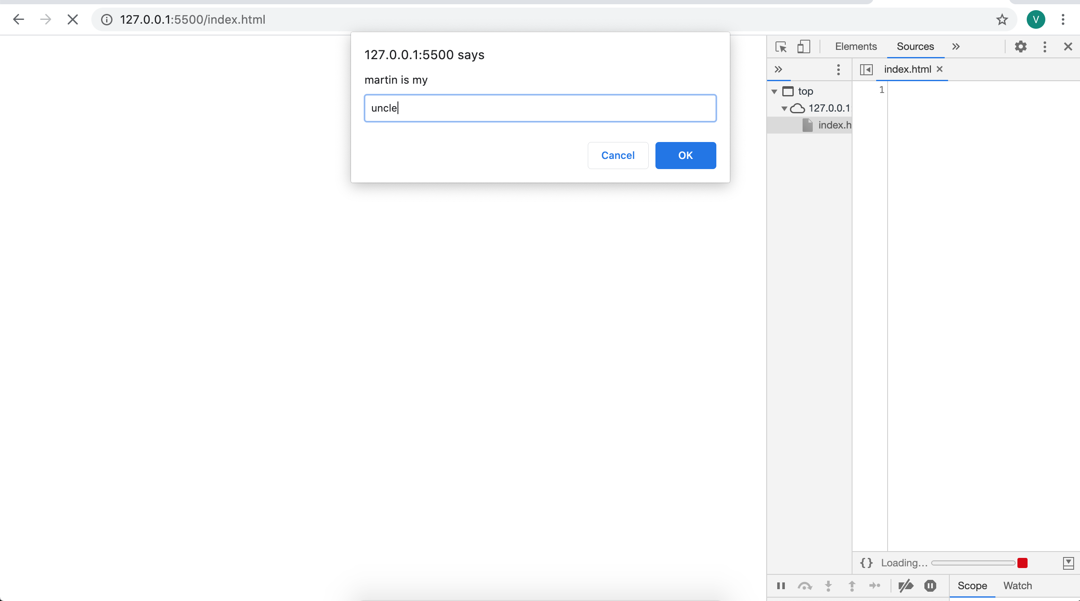

【6. Discussion】

【7. Comment】

Score: Instructor： Date:

